**WEB DESIGN**

**PROJECT REPORT**

| **PROJECT TEAM** | |
| --- | --- |
| **Student No.** | **Student Names** |
| 22103902 | Luis Navarro |
| 20232136 | Yitzu Lee |
| 21174237 | Yueh Ming Teng |

**Asian Film Festival**

**(Team A)**

[**https://luisnavarrot.github.io/Asian-Film-Festival-Dublin/**](https://luisnavarrot.github.io/Asian-Film-Festival-Dublin/)

**Section 1**

**Overview**

At the beginning, our group originally wanted to make a selling-products oriented e-commerce website. However, the e-commerce website required a complex shopping cart and payment which exceeded our capabilities at the moment. Therefore, after discussion, we think that the most important part of this homework is to be able to show what we have learned in class and extra-curricular knowledge at the same time. In addition, the three of us are very interested in movies, so we decided to choose movies as the theme of the project.

The film festival ticket website can combine what we learned before, such as table, forms, and javascript validation and other functions, and we also believe that a simple but easy-to-understand website design is most suitable. Although the website can still be improved,our team is very satisfied overall.

**Design**

## **Research / Investigation**

The types of websites which are similar to ours in the market are other film festival websites, movie theatre websites and film review websites, and the competitors we mainly refer to are the following three websites.

**1.Dublin International Film Festival**

-Advantages: The overall tone of the website is consistent and concise, which is quite suitable for users to read.

-How to apply: At the first stage of discussion, we had agreement on colour would be used. Therefore, it is planned that everyone should carry out the main three colours when designing the webpage, so as to maintain the consistency of the website.

**2.Taipei Film Festival**

-Advantages: The sitemap of the website is clear, and the website design is beautiful and dynamic.

-How to apply: We refer to the sitemap of this website and simplify it in our own website.

**3.IMDb**

-Advantages: The information on the movie introduction page is quite clear without too much complicated details.

-How to apply: Take the reference from the website’s layout , try to present the most information to users in a limited space.

## Requirements & Technical Approach

The most important functions of the film festival website should include event updates, movie introduction, and the function of booking tickets. Finally, we also have added a membership system to improve the overall website facilities as well.

Regarding the sitemap of the website,we took the references from the other similar websites,and then decided which pages would be created.Regarding the images on the movie introduction page,we used the photoshop and compress tool to resize all images to the most suitable one,and then displayed them on the webpages. Regarding the ticket pages,we took the references from the design of javascript dropdown action,tried to make it more like for commercial use.Regarding the membership form,we took the references from the javascript with phone number and agreeing on terms and condition to make it more real.

## **Sitemap & Wireframe**

## Sitemap

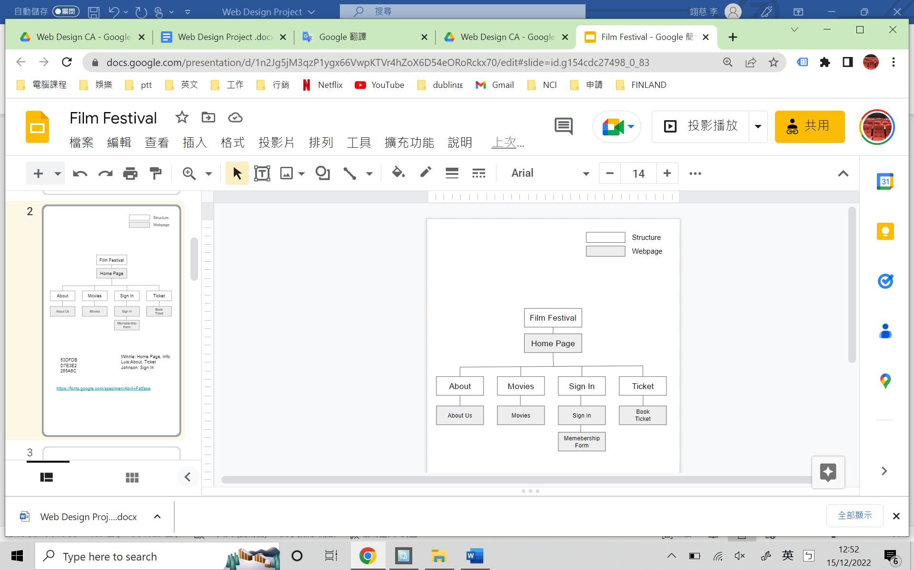

Wireframe

Homepage

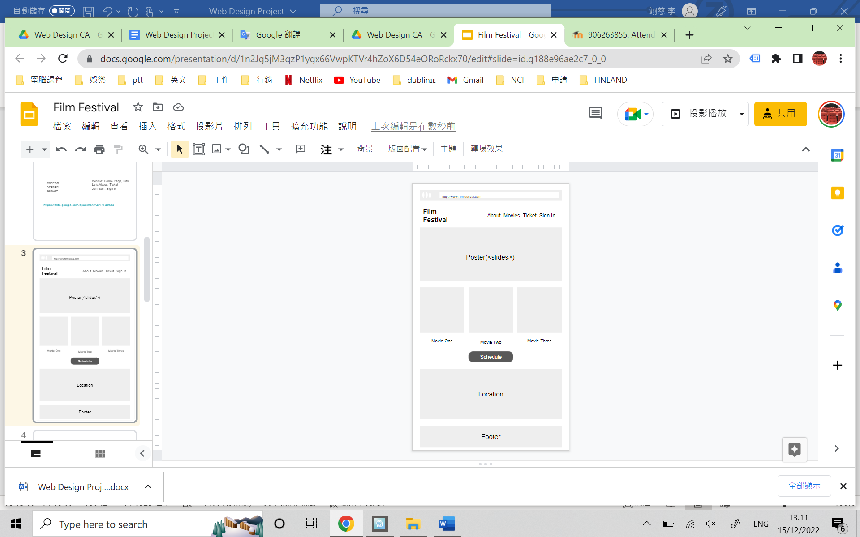

Movies page

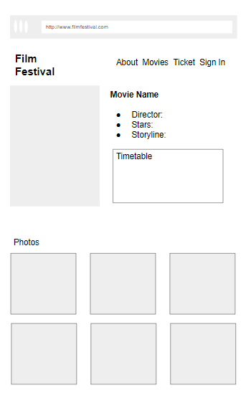

Sign In page

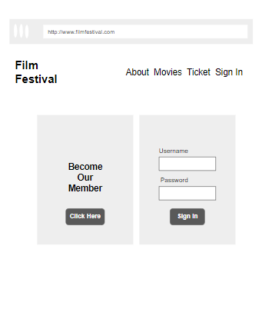

Membership page

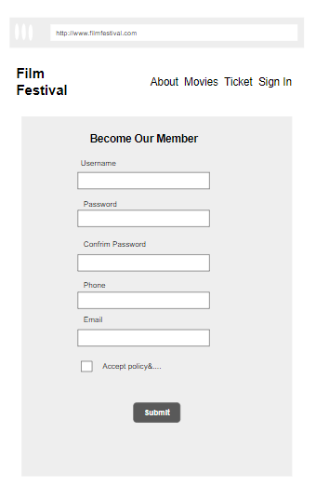

Ticket Page

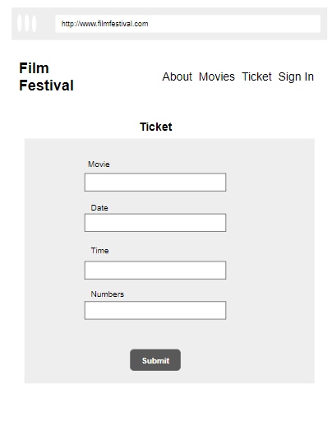

About Us

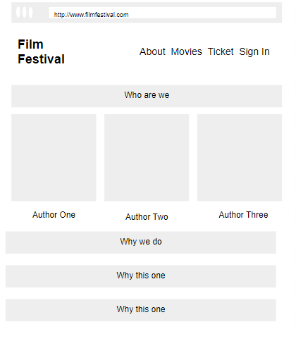

**Section 2**

**Development**

The first steps we took before coding were to decide the colors and fonts we would all use to develop the project, make the wireframe and choose which member would be in charge of which pages, after that we create a google drive shared folder in which we created all the folders we would use (images, js, css, pages).

After that each member created a base css and header nav bar, we choose wich one was the best looking one and decided to use it for the rest of the pages.

Each member would develop their own 2 pages using the common css and Java Scipt, we used a whatsapp group to communicate the team about any changes or updates to the common files and once we all develop our pages we got together and added the last links, check that it was all compatible and that we were all using the same version of bootstrap.

We checked everybody's code and looked for errors as well as for pieces of code we didn't understand, and explained to each other so we all would know how it all worked.

An important part of this project was the use of classes and IDs to avoid changing the formats used in other members' pages.

Some of the biggest issues we found were:

1.- At the beginning of the pages code we used <!DOCTYPE> which created an error with the use of the common CSS, after trying to find solutions on google, changing the code to different computers and copying parts of each others code into other pages we realize that this particular word (<!DOCTYPE>) was the issue and it was resolved by just deleting it, this problem seems to be caused by an incompatibility between laptops bought in Taiwan and Ireland.

2.- Some colors were not matching. Even Though we chose colors together and have used the same HEX codes for them, on some parts of our pages colors didn't seem to match. This problem was caused by the use of different links/versions of the bootstrap and was easily corrected by using the latest version on all of our pages.

3.- Another problem we faced was the use of the same css file, each member would download the file modified and uploaded again what would create and issue if two people try to do it at the same time, we solve this by creating a base css with the common ids and classes for all pages and each one created a personal css file to work on their pages and we at the end merge them together in a single file.

All our code was validated as shown in the next section.

**Validation & Errors**

**external.css:**

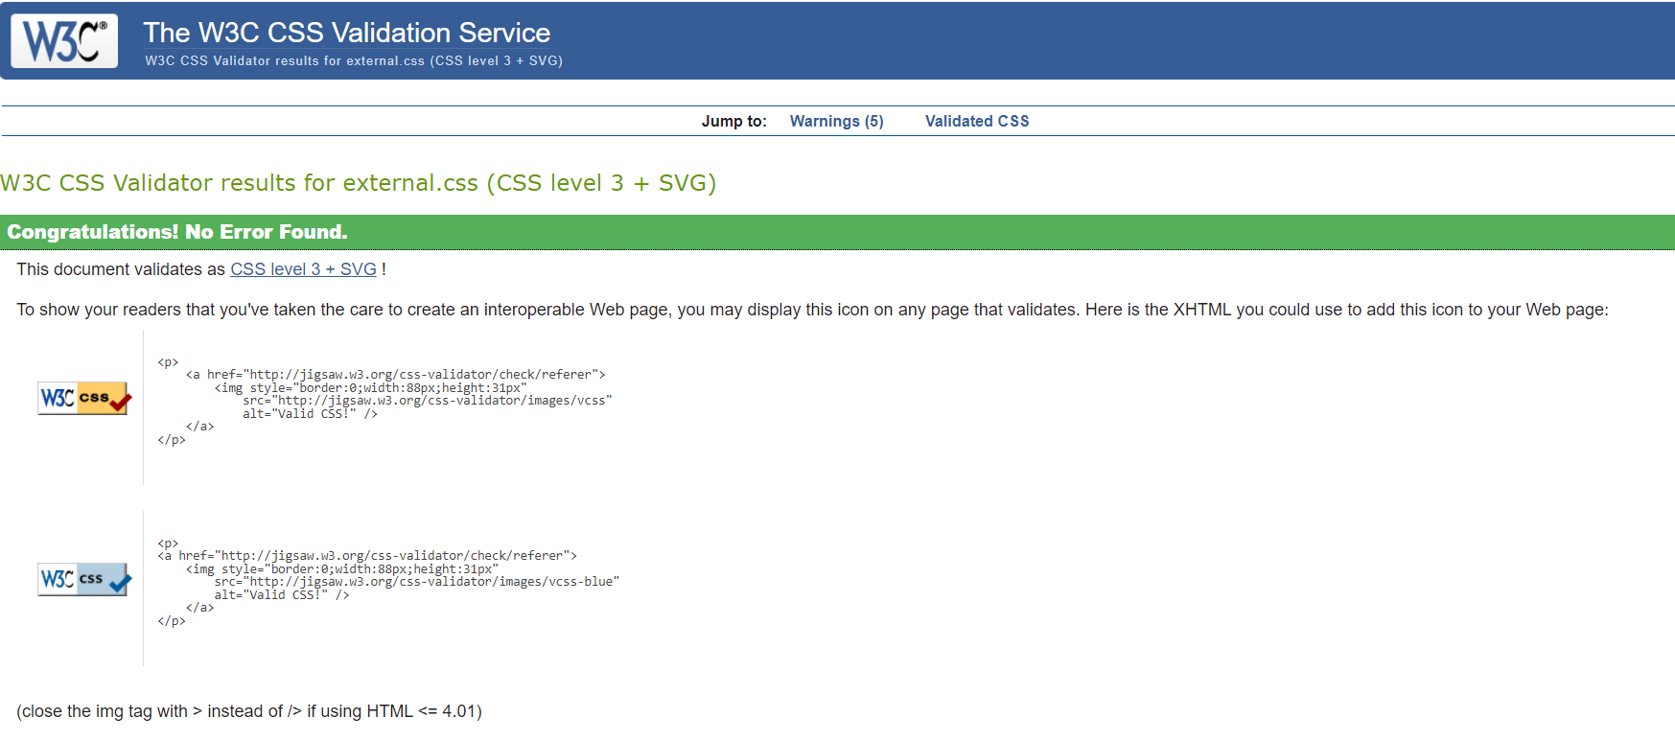

Index:

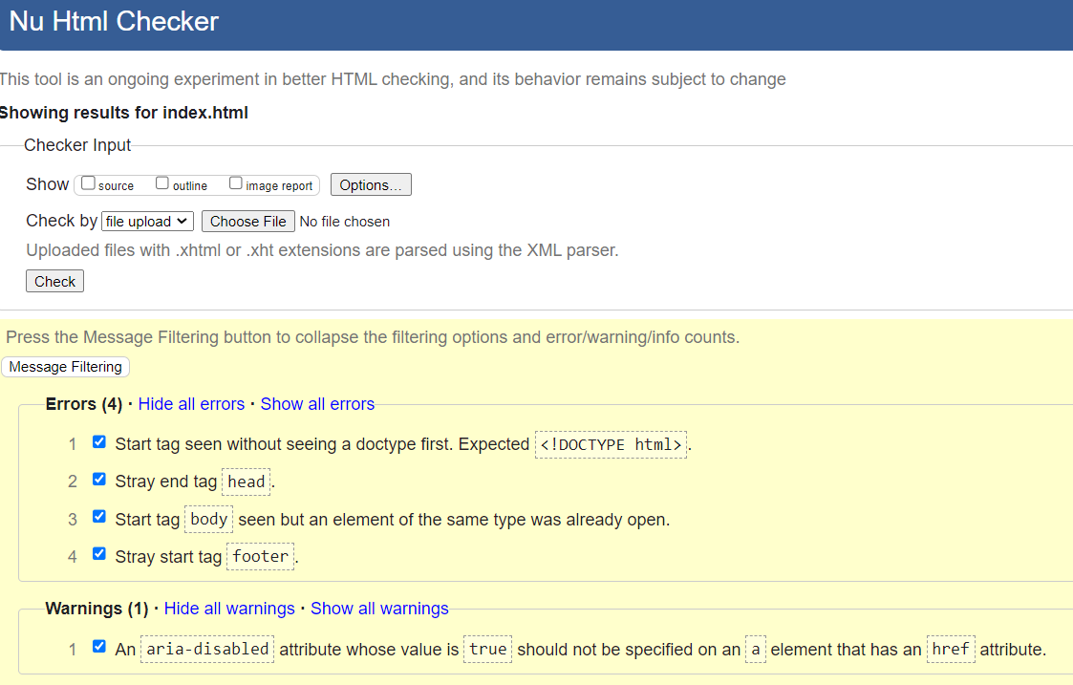

About_Us:

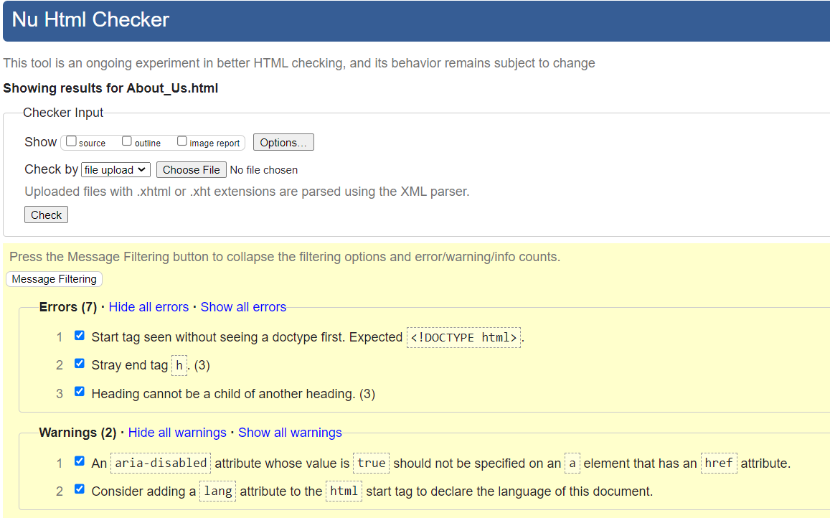

Movies:

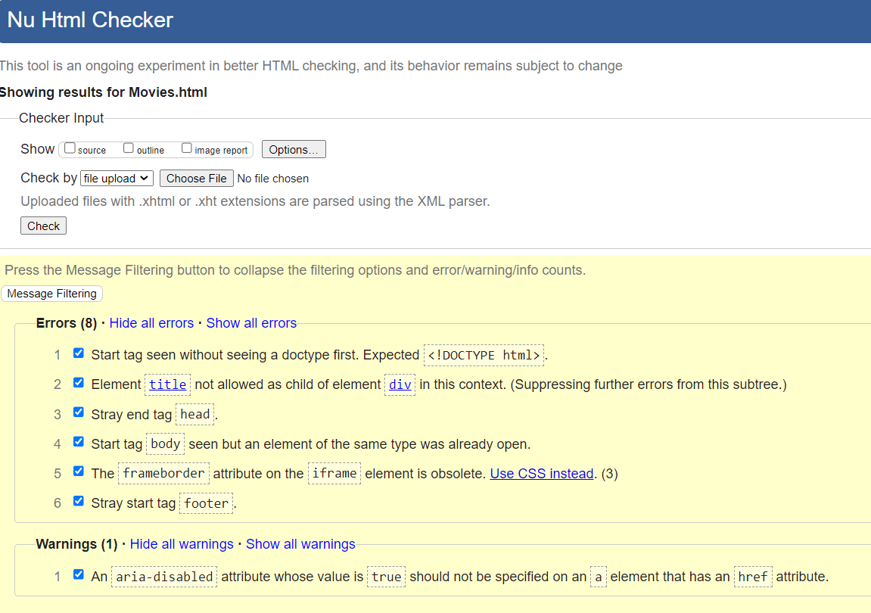

—Div tag can contain title tag:

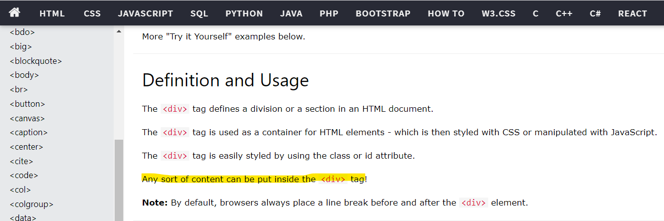

Tickets:

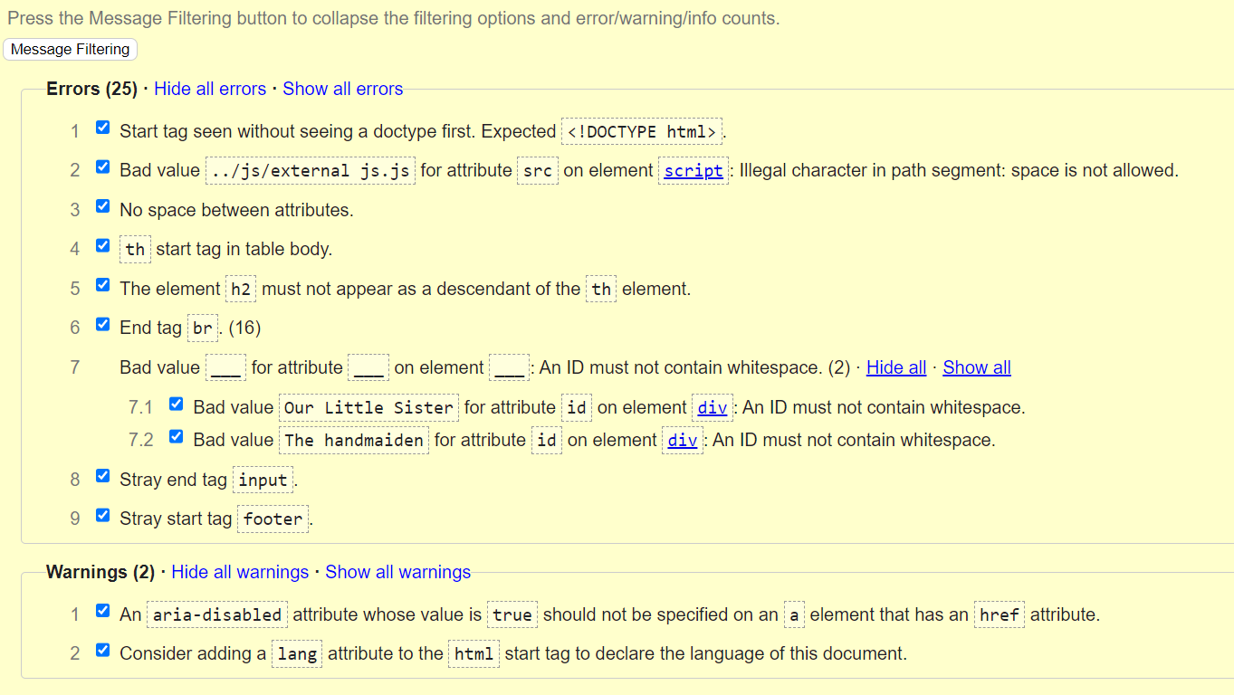

Sign_In:

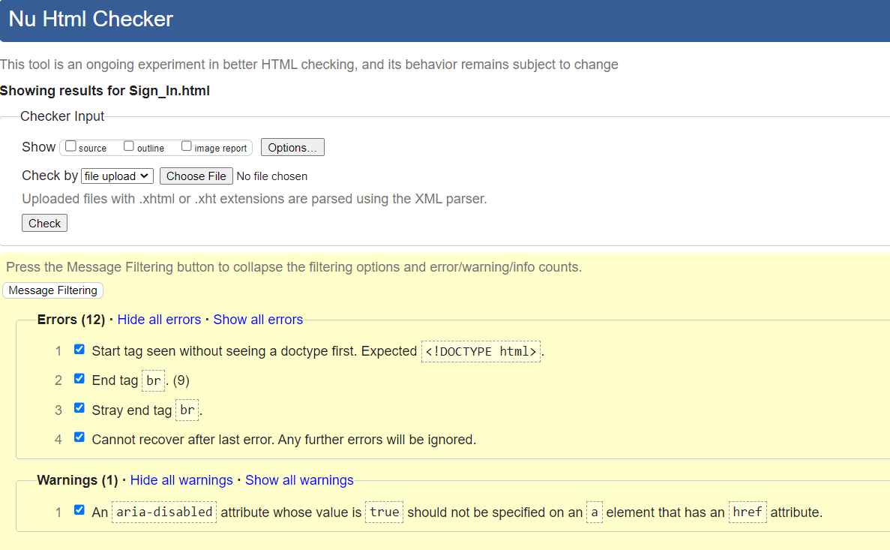

membership:

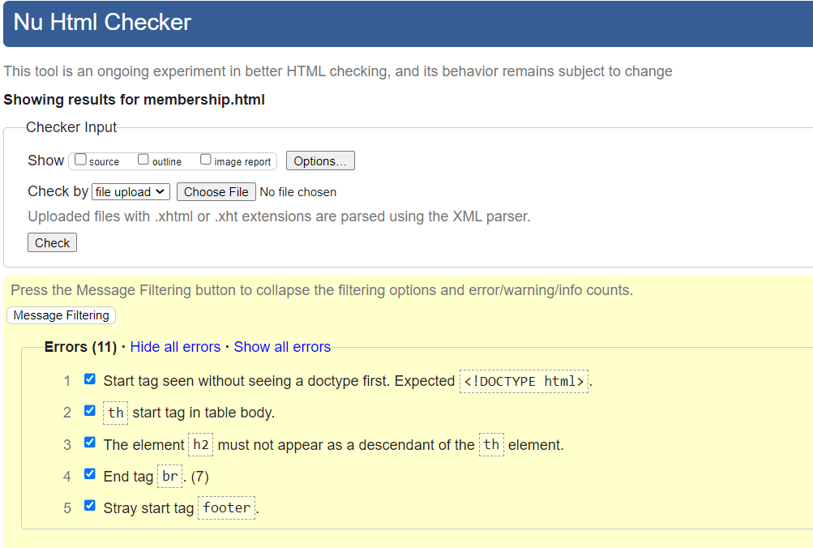

**Section 3**

**Deployment**

For the deployment of this page we decided to use github and uploaded only the final version of our page. We decided to go with this hosting option because it was the one we learned how to use in classes and is the most used in the sector.

Our web pages URL is:

[**https://luisnavarrot.github.io/Asian-Film-Festival-Dublin/**](https://luisnavarrot.github.io/Asian-Film-Festival-Dublin/)

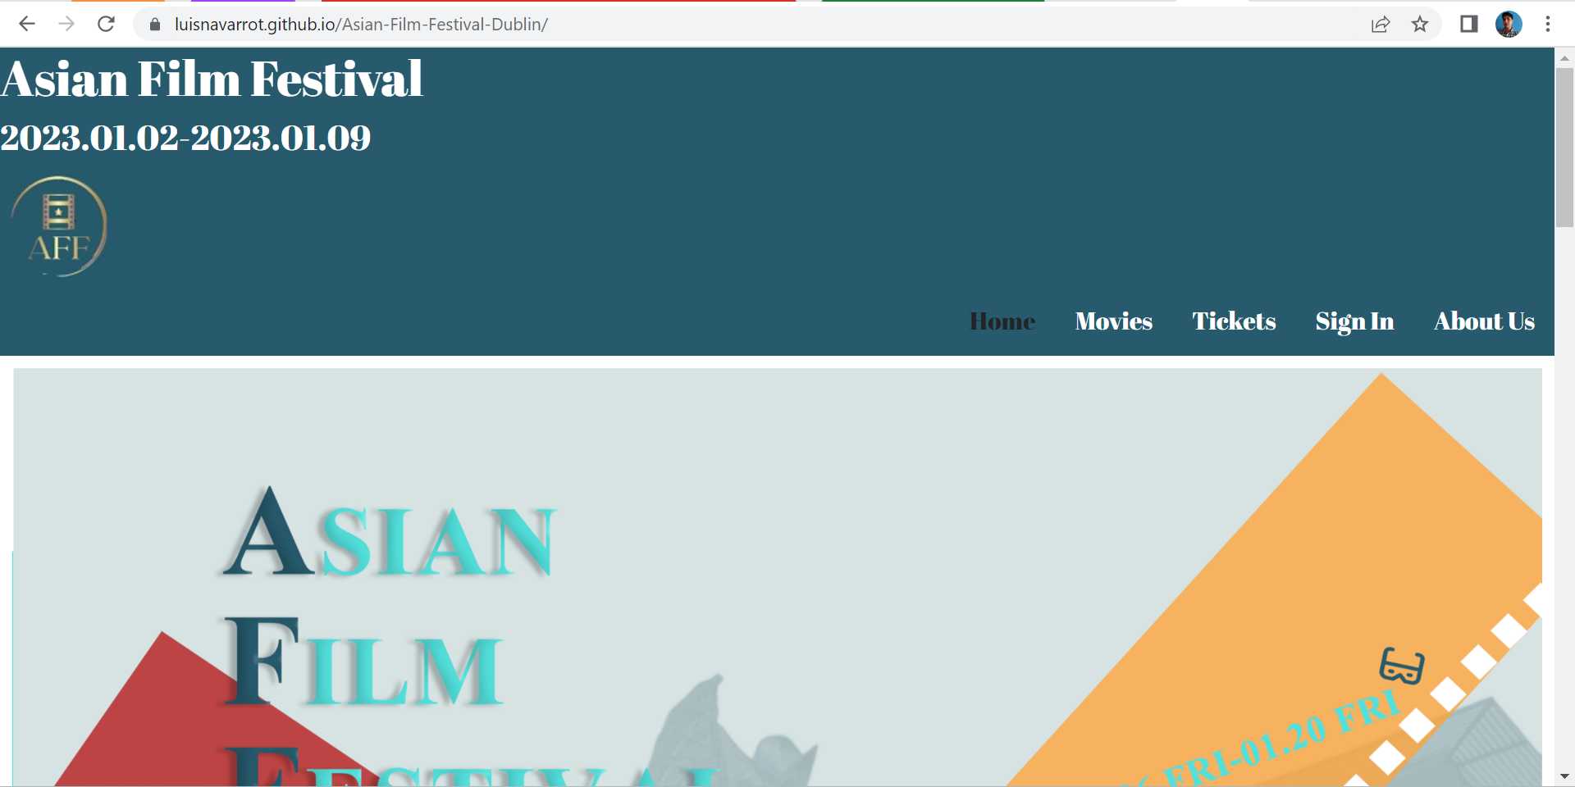

**Section 4**

**User Testing**

Tickets:

| 1.input nothing and submit. | 2.No input day, hour, and seat. |
| --- | --- |
| 3.No input hour, and seat. | 4.No input seat. |
| 5.input valid information. |  |

Sign_In:

| 1.No input username and password and submit. | 2.No input password and submit. |
| --- | --- |
| 3.input valid information. | 4.Hit “Click here” and click ok |

membership:

| 1.No input and submit. | 2.Input username and submit. |
| --- | --- |
| 3.input username and password and sublmit. | 4.password and confirm password are not match. |
| 5.Input confirm password, and delete password and submit. | 6.No input mobile number and e-mail, and submit. |
| 7.The first index of mobile number is not 0, and submit. | 8.No input email, and submit. |
| 9.input invalid email, and submit. | 10.input valid information, and submit. |

**Section 5**

**Project Team**

First of all, we determined which tasks need to be carried out, and the priority of the tasks (following Gantt chart), and stipulated the deadline of each stage.

In addition, different tasks are assigned to each person according to the requirements of the CA. The more difficult thing should be the time arrangement, because we still have other homework to be completed at the same time, and some people also have other jobs, but in the end everyone successfully completed this homework and finally achieved the scheduled results.

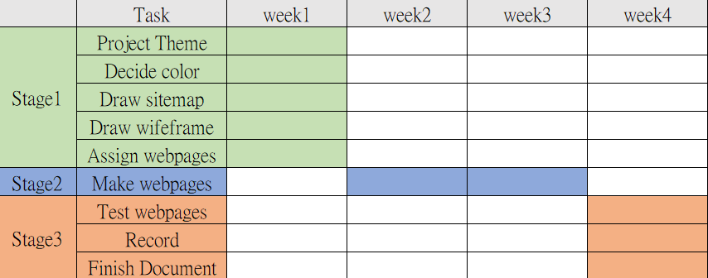

**Task Assignment:**

Yueh Ming Teng: Sign in page, membership page

Yitzu Lee: Home page, Movies page, sitemap, wireframe

Luis Navarro: About Us page,Ticket Page, Deployment

Together: Decide project theme, color, test pages, record, documents

**Section 6**

**Conclusion**

**YuehMingTeng**

We have achieved the aim that we have set at the first. In the Sign_In and membership sites, the javascript code most are referred to *w3schools*, *stackoverflow*, and *youtube demonstration*. If I had more time to learn the foundation of javascript and how it works with html, I would use a better way to present the javascript syntax.

**Yitzu Lee**

Our teamwork and the process of doing this CA is quite harmonious, and also achieved the goal we set at the beginning, so I am quite satisfied with the result. Of course, this cannot be a website that can be used directly online, but I think the basic structure is similar to a real commercial website, and then more details and functions will be improved. If I have more time, I personally would like to develop a discussion area for movies, so that users can leave comments on movies. In addition, a CRM system can also be considered.

**Luis Navarro**

All the goals we set at the beginning were achieved successfully, it took us less time than the one we had planned at first and I am proud of our work.

Nevertheless there are always things we can improve, in our case I think that using githubs features of branches and versions would have made our job easier.

Our CSS document contains many different Ids and classes that although they are all different and are used I believe we could manage them in a better way in order to have less.

Some of the things I consider the most helpful were the small but constant meetings we had, we were talking to each other and showing the code all the time, we planned and executed everything without delays, and we had a great and open communication throughout the project.

**Section 7: References / Appendix**

Sign_In.html:

<https://www.w3schools.com/jsref/met_win_open.asp>

membership.html:

<https://www.w3schools.com/jsref/jsref_fromcharcode.asp>

<https://www.w3schools.com/jsref/event_key_which.asp>

<https://www.w3schools.com/jsref/event_preventdefault.asp#gsc.tab=0>.

<https://www.youtube.com/watch?v=nRHCoOVSu5k>

<https://stackoverflow.com/questions/21523730/html-checkbox-submit-button-by-agreeing-on-terms-and-condition>

<https://www.w3schools.com/jsref/dom_obj_checkbox.asp>

<https://linuxhint.com/phone-numbers-in-javascript/>

competitior:

[https://www.diff.ie/](https://www.diff.ie/)/)

<https://www.taipeiff.taipei/>

<https://www.imdb.com/>

hompage:

https://www.w3schools.com/howto/howto_js_topnav.asp

https://www.w3schools.com/css/css_navbar.asp

<https://youtu.be/aRE2Zge1rUI>

movie introduction:

<https://www.w3schools.com/css/css_image_gallery.asp>

<https://stackoverflow.com/questions/6192446/javascript-dropdown-action>

<https://getbootstrap.com/docs/5.0/components/card/>

https://getbootstrap.com/docs/5.2/components/navbar/